CS 4354 Database Systems

Name:____Chen Zhang_________________

Question 1. (5 pts)

Try to map the relational schema of Figure 9.2 into an ER schema. This is part of
a process known as reverse engineering, where a conceptual schema is created for
an existing implemented database. State any assumptions you make if you have.
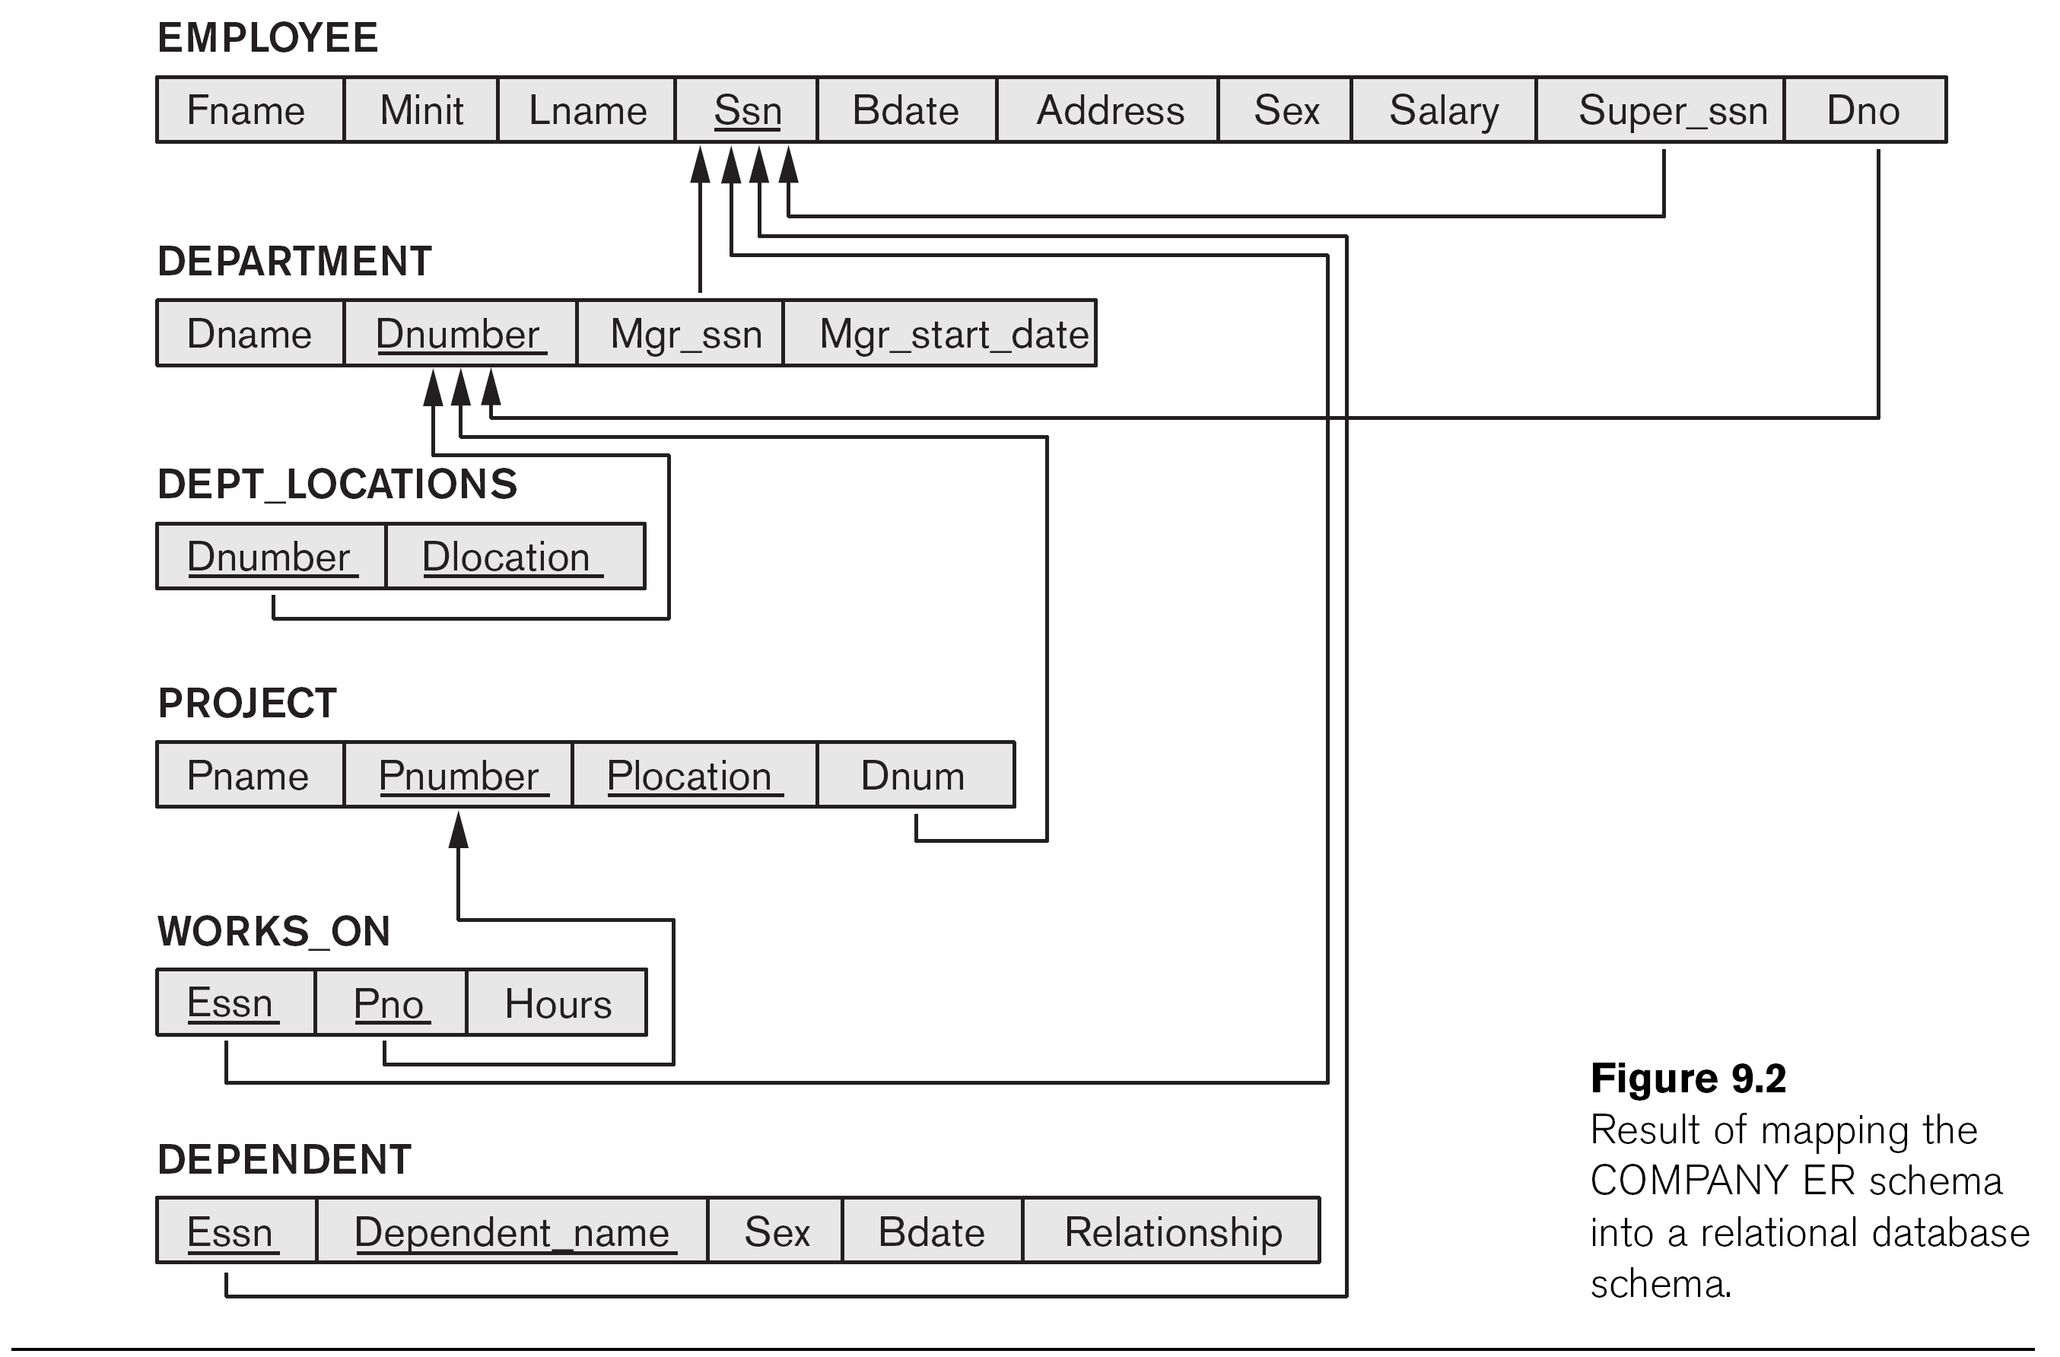

Answer:

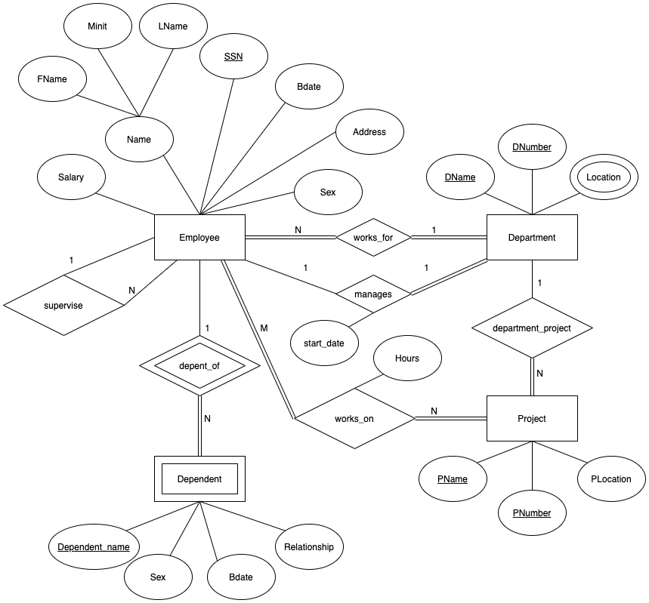

Question 2. (10 pts)

Try to map the ER schema of Figure 7.20 into a relational schema. State any assumptions you make if you have.

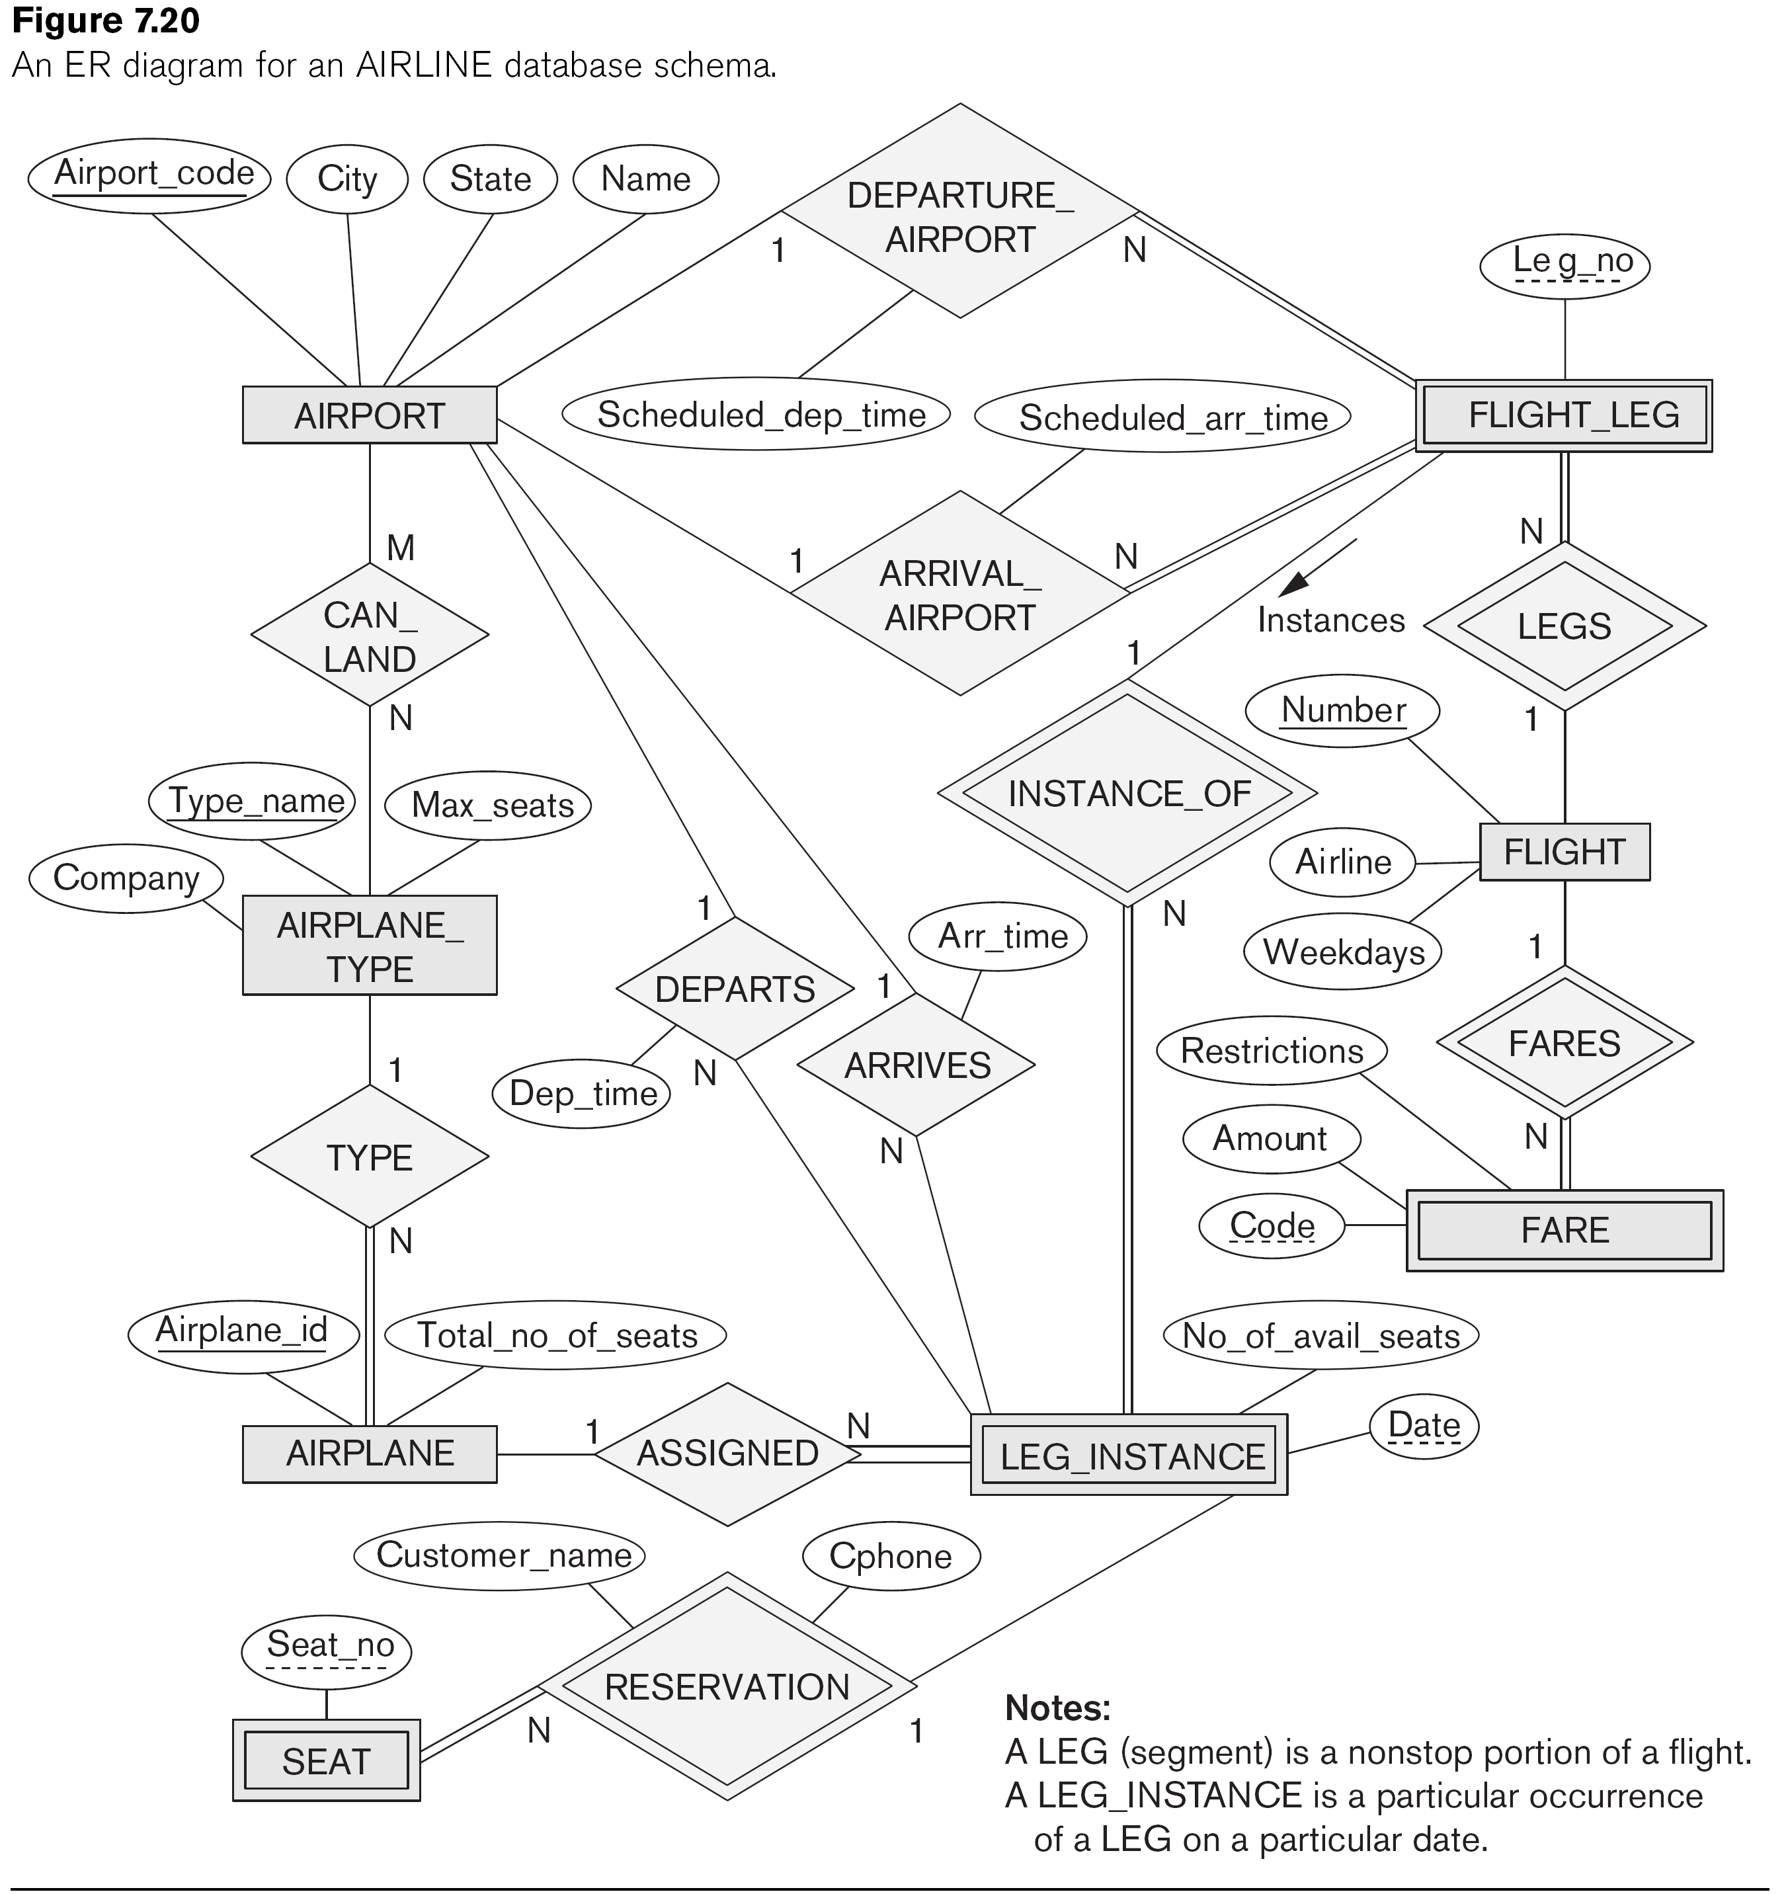

Answer:

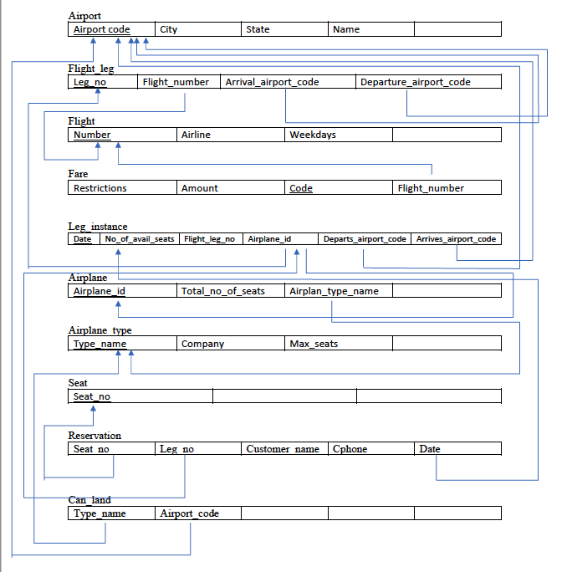

For 1 to N relations I add a foreign key to the N entity in order map to 1.
For M to N relations I created a table to map both primary key from M and N entities.
Question 3. (5 pts)

Try to map the ER and EER schema of Figure 8.7 into a relational schema. State any assumptions you make if you have.

Answer:
